**Lab 4. Database Objects**

1. **Create the Customer table with the following columns.**

Customerid Number(5)

CustomerName Number(10)

Address1 Varchar2(30)

Address2 Varchar2(30)

Solution :

CREATE TABLE CUSTOMER (CUSTOMERID NUMBER(5) ,CUSTOMERNAME NUMBER(10),ADDRESS1 VARCHAR2(30),ADDRESS2 VARCHAR2(30));

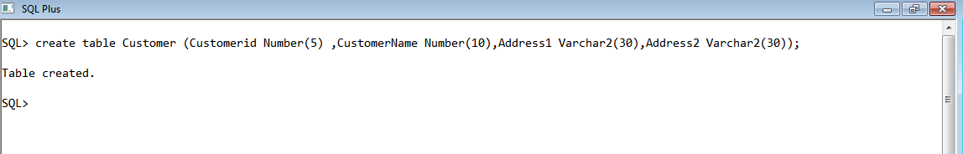

**2. Modify the Customer table CustomerName column of datatype with Varchar2(30).**

**CustomerName should not accept Nulls.**

Solution :

ALTER TABLE CUSTOMER MODIFY CUSTOMERNAME VARCHAR2(30) NOT NULL;

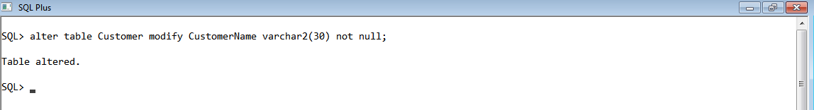

**3. Add the following Columns to the Customer table.**

Gender Varchar2(1)

Age Number(3)

PhoneNo Number(10)

Solution :

ALTER TABLE CUSTOMER ADD (GENDER VARCHAR2(1),AGE NUMBER(3),PHONENO NUMBER(10));

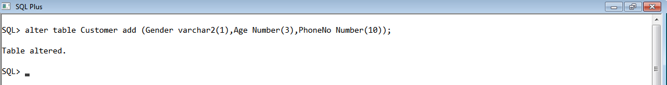

**4. Insert rows with the following data in to the Customer table.**

Insert into customer values: (1000, ‘Allen’, ‘#115 Chicago’, ‘#115 Chicago’, ‘M’, ‘25,

7878776’)

In similar manner, add the below records to the Customer table:

• 1000, Allen, #115 Chicago, #115 Chicago, M, 25, 7878776

• 1001, George, #116 France, #116 France, M, 25, 434524

• 1002, Becker, #114 New York, #114 New York, M, 45, 431525

Solution :

INSERT INTO CUSTOMER VALUES (1000, 'ALLEN', '#115 CHICAGO', '#115 CHICAGO', 'M', 25,7878776);

INSERT INTO CUSTOMER VALUES (1001, 'GEORGE', '#116 FRANCE', '#116 FRANCE', 'M', 25,434524);

INSERT INTO CUSTOMER VALUES (1002, 'BECKER', '#114 NEW YORK', '#114 NEW YORK', 'M', 25,431525);

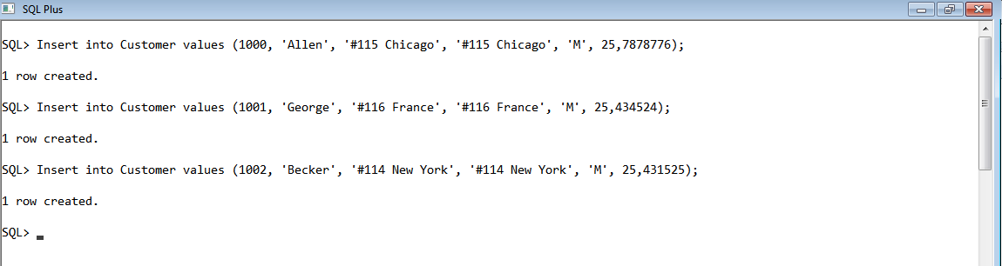

**5. Add the Primary key constraint for Customerld with the name Custld_Prim.**

Solution :

ALTER TABLE CUSTOMER ADD CONSTRAINT CUSTID_PRIM PRIMARY KEY (CUSTOMERID);

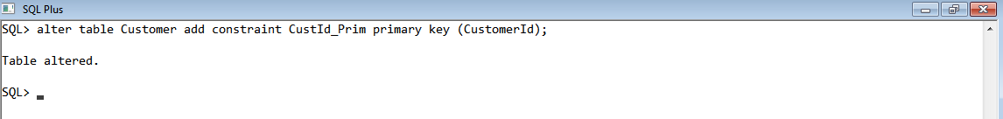

**6. Insert the row given below in the Customer table and see the message generated**

**by the Oracle server.**

**1002, John, #114 Chicago, #114 Chicago, M, 45, 439525**

Solution : INSERT INTO CUSTOMER VALUES (1002, 'JOHN', '#114 CHICAGO', '#114 CHICAGO', 'M', 45,439525);

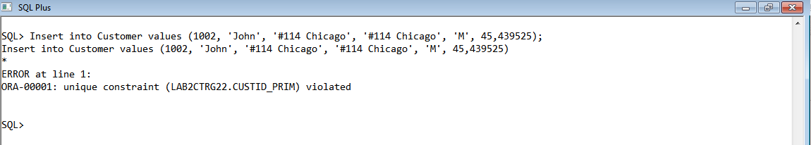

**7. Disable the constraint on CustomerId, and insert the following data:**

**• 1002, Becker, #114 New York, #114 New york , M, 45, 431525**

**• 1003, Nanapatekar, #115 India, #115 India , M, 45, 431525**

Solution :

select constraint_name,constraint_type from user_constraints where table_name='CUSTOMER';

alter table customer disable constraint CUSTID_PRIM;

Insert into Customer values (1002, 'Becker', '#114 New York', '#114 New York', 'M', 45,431525);

Insert into Customer values (1003, 'Nanapatekar', '#115 India', '#115 India', 'M', 45,431525);

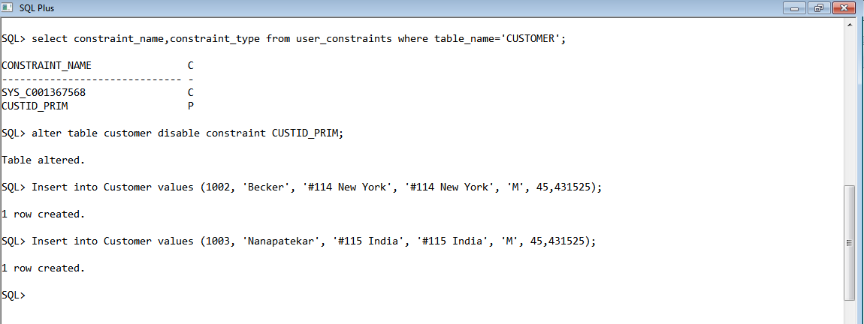

**8. Enable the constraint on CustomerId of the Customer table, and see the message**

**generated by the Oracle server.**

Solution : ALTER TABLE CUSTOMER ENABLE CONSTRAINT CUSTID_PRIM;

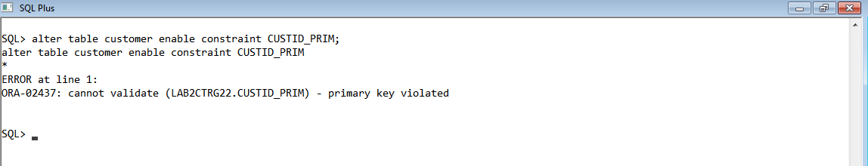

**9. Drop the constraint Custld_Prim on CustomerId and insert the following Data. Alter**

**Customer table, drop constraint Custid_Prim.**

**• 1002, Becker, #114 New York, #114 New york , M, 45, 431525, 15000.50**

**• 1003, Nanapatekar, #115 India, #115 India , M, 45, 431525, 20000.50**

Solution :

ALTER TABLE CUSTOMER DROP CONSTRAINT CUSTID_PRIM;

INSERT INTO CUSTOMER VALUES (1002, 'BECKER', '#114 NEW YORK', '#114 NEW YORK', 'M', 45,431525);

INSERT INTO CUSTOMER VALUES (1003, 'NANAPATEKAR', '#115 INDIA', '#115 INDIA', 'M', 45,431525);

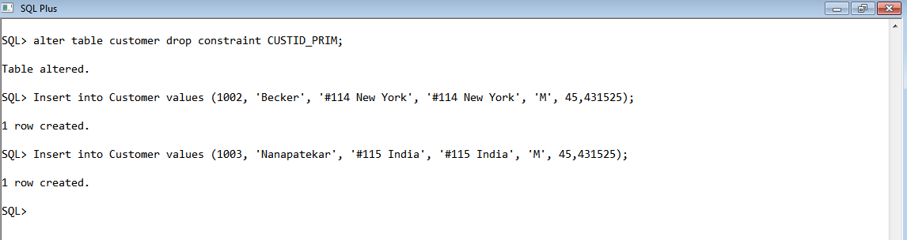

**10. Delete all the existing rows from Customer table, and let the structure remain itself**

**using TRUNCATE statement.**

Solution : Truncate Table Customer;

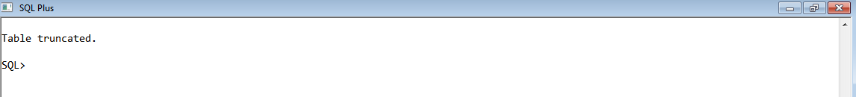

**11. In the Customer table, add a column E_mail.**

Solution : ALTER TABLE CUSTOMER ADD (E_MAIL VARCHAR2(30));

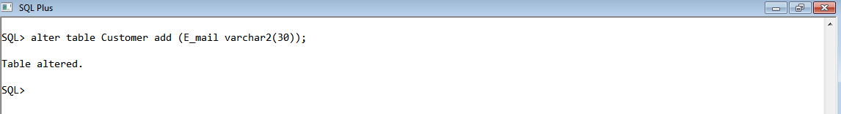

**12. Drop the E_mail column from Customer table.**

Solution : ALTER TABLE CUSTOMER DROP COLUMN E_MAIL;

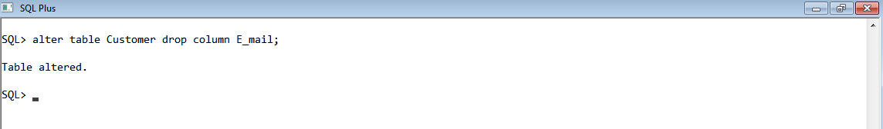

**13. Add a new column EmailId to Customer table.**

Solution : ALTER TABLE CUSTOMER ADD (EMAILID VARCHAR2(30));

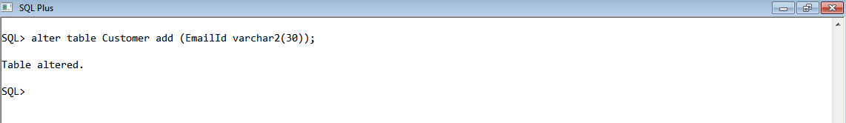

**14. Mark EmailId column as unused before dropping it.**

Solution : ALTER TABLE CUSTOMER SET UNUSED COLUMN EMAILID;

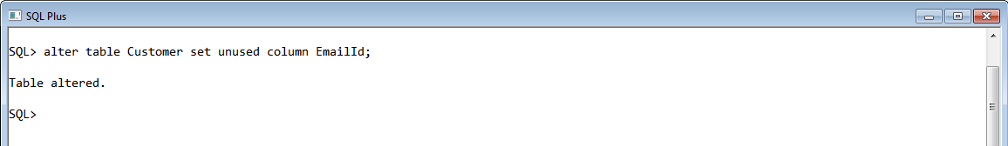

**15. Drop the unused EmailId column from the Customer table.**

Solution : ALTER TABLE CUSTOMER DROP UNUSED COLUMNS;

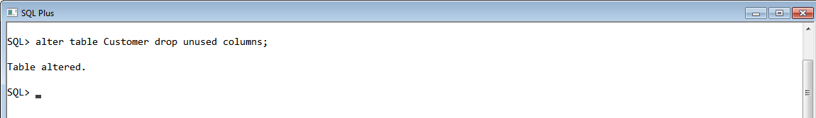

**16. Define the COMMENT ‘Customers Details’ for Customer table.**

Solution : COMMENT ON TABLE CUSTOMER IS 'CUSTOMER DETAILS';

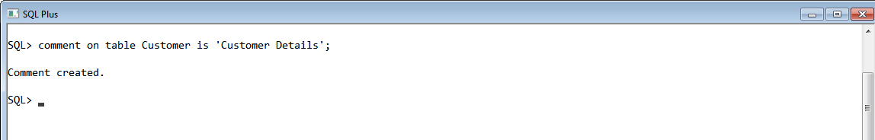

**17. Use Data Dictionary USER_TAB_COMMENTS to view the created comment.**

Solution : SELECT TABLE_NAME,COMMENTS FROM USER_TAB_COMMENTS WHERE TABLE_NAME='CUSTOMER';

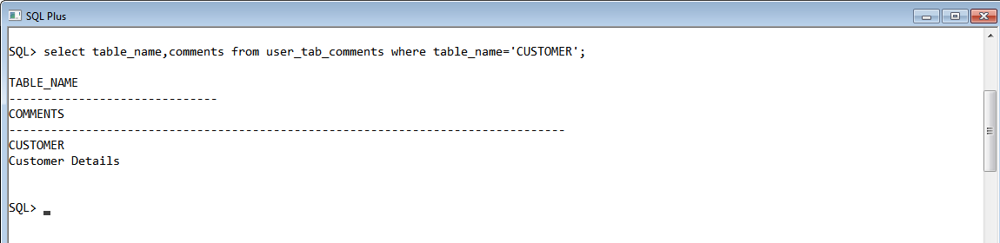

**18. Define the COMMENT ‘Personal Contact no’ for the phoneno column of the**

**Customer table.**

Solution : COMMENT ON COLUMN CUSTOMER.PHONENO IS 'PERSONAL CONTACT NO';

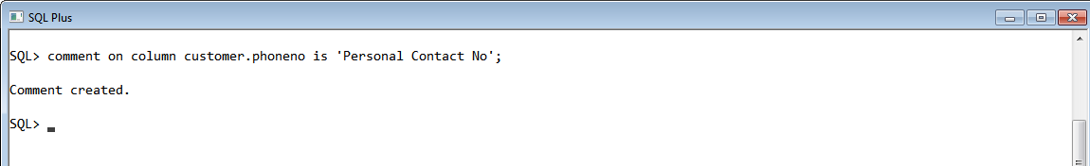

**19. Use Data Dictionary USER_COL_COMMENTS to view the created comment.**

Solution : SELECT COLUMN_NAME,COMMENTS FROM USER_COL_COMMENTS WHERE TABLE_NAME='CUSTOM ER' AND COLUMN_NAME='PHONENO';

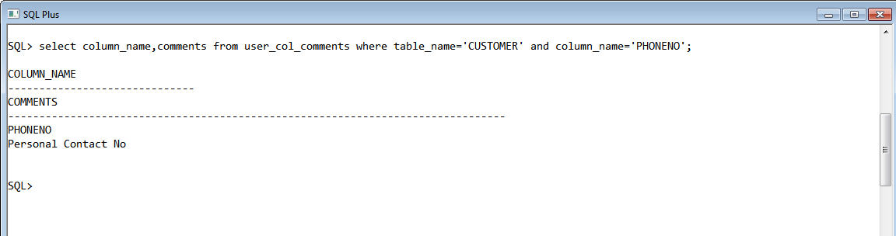

**20. Create the Suppliers table based on the structure of the Customer table. Include**

**only the CustomerId, CustomerName, Address1, Address2, and phoneno columns.**

**Name the columns in the new table as SuppID, SName, Addr1, Addr2, and Contactno**

**respectively.**

Solution : CREATE TABLE SUPPLIERS AS SELECT CUSTOMERID AS SUPPID,CUSTOMERNAME AS SNAME ,ADDRESS1 AS ADDR1,ADDRESS2 AS ADDR2,PHONENO AS CONTACTNO FROM CUSTOMER WHERE 1= 2;

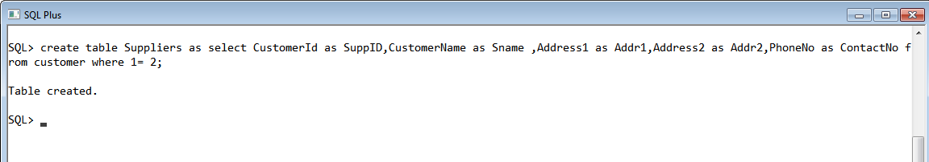

**21. Drop the above table and recreate the following table with the name**

CustomerMaster.

CustomerId Number(5) Primary key(Name of constraint is CustId_PK)

CustomerName Varchar2(30) Not Null

Addressl Varchar2(30) Not Null

Address2 Varchar2(30)

Gender Varchar2(l)

Age Number(3)

PhoneNo Number(10)

Solution : CREATE TABLE CUSTOMERMASTER (CUSTOMERID NUMBER(5),CUSTOMERNAME VARCHAR2(30) NOT NULL, ADDRESS1 VARCHAR2(30) NOT NULL, ADDRESS2 VARCHAR(30), GENDER VARCHAR2(1),AGE NUMBER(3), PHONENO NUMBER(10), CONSTRAINT CUSTID_PK PRIMARY KEY(CUSTOMERID));

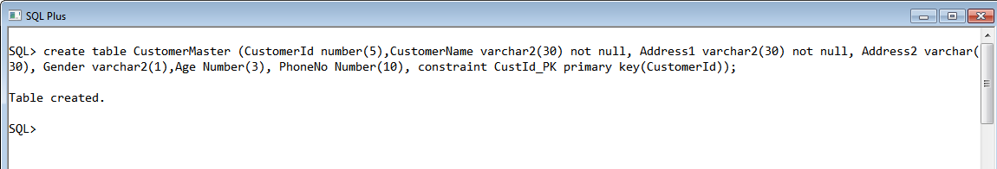

**22. Create the AccountsMaster table with the following Columns. Use sequence to**

**generate Account number**

Customerld Number(5)

AccountNumber Number(10,2) Primary key(Name of constraint is Acc_PK)

AccountType Char(3)

LedgerBalance Number(10,2) Not Null

Solution : CREATE TABLE ACCOUNTMASTER (CUSTOMERID NUMBER(5), ACCOUNTNUMBER NUMBER(10,2), ACCOUNTTYPE CHAR(3), LEDGERBALANCE NUMBER(10,2) NOT NULL,CONSTRAINT ACC_PK PRIMARY KEY(ACCOUNTNUMBER));

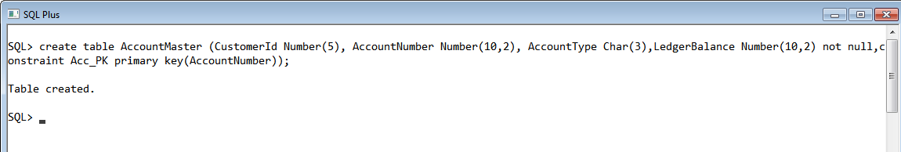

**23. Relate AccountsMaster table and CustomerMaster table through Customerld**

**column with the constraint name Cust_acc.**

Solution : ALTER TABLE ACCOUNTMASTER ADD CONSTRAINT CUST_ACC FOREIGN KEY (CUSTOMERID) REFERENCES CUSTOMERMASTER(CUSTOMERID);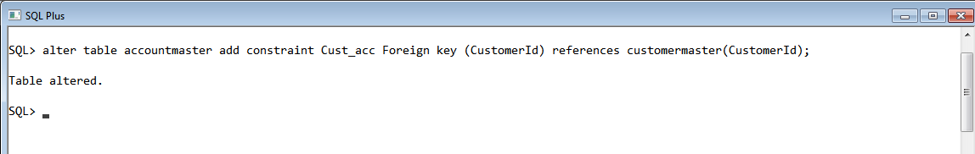

**24. Insert the following rows to the CustomerMaster table:**

• 1000, Allen, #115 Chicago, #115 Chicago, M, 25, 7878776

• 1001, George, #116 France, #116 France, M, 25, 434524

• 1002, Becker, #114 New York, #114 New York, M, 45, 431525

Solution :

insert into CustomerMaster values(1000,'Allen','#115 Chicago','#115 Chicago','M',25,7878776);

insert into CustomerMaster values(1001,'George','#116 France','#116 France','M',25,434524);

insert into CustomerMaster values(1002,'Becker','#114 New York','#114 New York','M',45,431525);

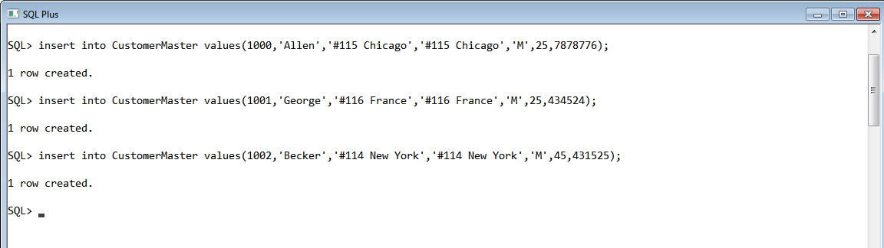

**25. Modify the AccountMaster table with the Check constraint to ensure AccountType**

**should be either NRI or IND.**

Solution :

ALTER TABLE ACCOUNTMASTER ADD CONSTRAINT CHK_CHECK CHECK(ACCOUNTTYPE='NRI' OR ACCOUNTTYPE='IND');

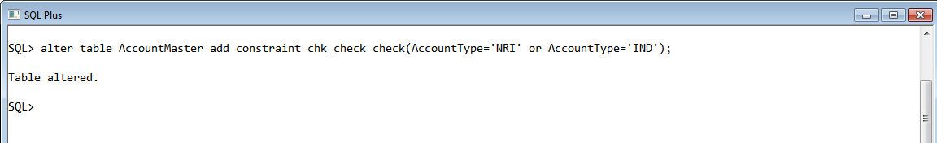

**26. Insert 5 rows into the AccountsMaster table:**

Solution :

Insert into AccountMaster values(1000,10,'IND',6000);

Insert into AccountMaster values(1001,11,'NRI',15000);

Insert into AccountMaster values(1002,12,'NRI',11000);

Insert into AccountMaster values(1000,13,'IND',16000);

Insert into AccountMaster values(1001,14,'IND',19000);

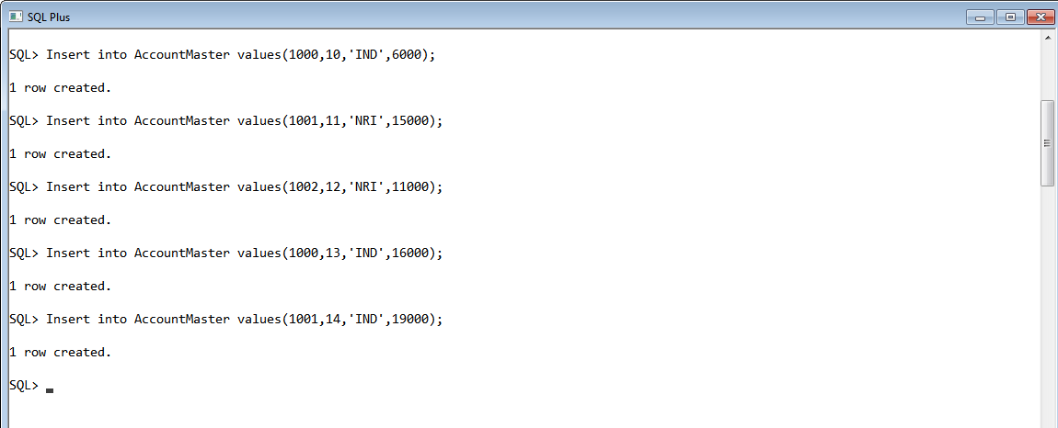

**27. Modify the AccountsMaster table keeping a Check constraint with the name**

**Balance_Check for the Minimum Balance which should be greater than 5000.**

Solution : ALTER TABLE ACCOUNTMASTER ADD CONSTRAINT CHK_CHECK1 CHECK(LEDGERBALANCE>5000);

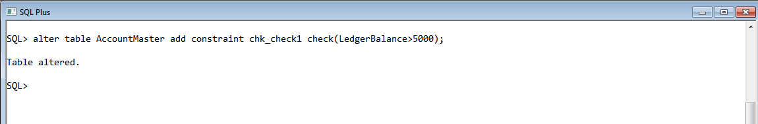

**28. Modify the AccountsMaster table such that if Customer is deleted from Customer**

**table then all his details should be deleted from AccountsMaster table.**

Solution :

ALTER TABLE CUSTOMER MODIFY CUSTOMERID NUMBER(5) UNIQUE;

ALTER TABLE ACCOUNTMASTER ADD CONSTRAINT FK_CUSTOMERID FOREIGN KEY (CUSTOMERID) REFERENCES CUSTOMER(CUSTOMERID) ON DELETE CASCADE;

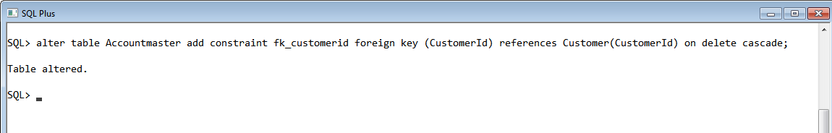

**29. Create Backup copy for the AccountsMaster table with the name ‘AccountDetails’.**

Solution : Create Table Accountdetails As Select * From Accountmaster;

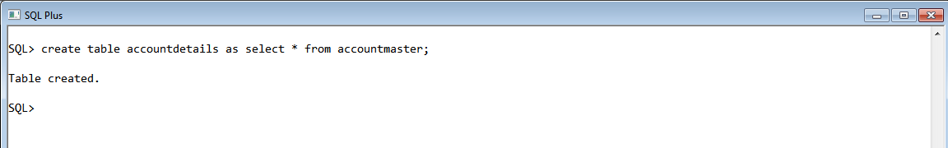

**30. Change the name of the AccountDetails table to ‘BackUpTable’ table.**

Solution : ALTER TABLE ACCOUNTDETAILS RENAME TO BACKUPTABLE;

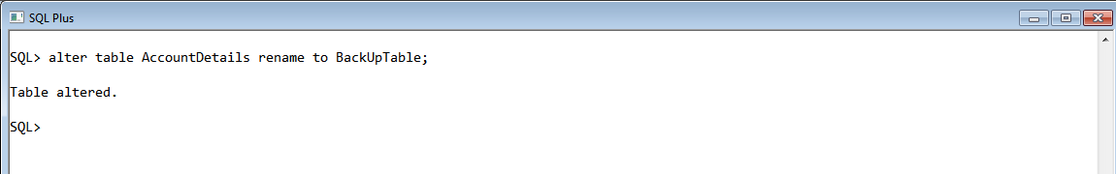

**31. Create a view ‘Acc_view’ with columns Customerld, CustomerName,**

**AccountNumber, AccountType, and LedgerBalance from AccountsMaster. In the view**

**Acc_view, the column names should be CustomerCode, AccountHolderName,**

**AccountNumber, Type, and Balance for the respective columns from AccountsMaster**

**table.**

Solution : CREATE VIEW ACC_VIEW AS SELECT CUSTOMERID AS CUSTOMERCODE,ACCOUNTNUMBER,AC COUNTTYPE AS TYPE,LEDGERBALANCE AS BALANCE FROM ACCOUNTMASTER;

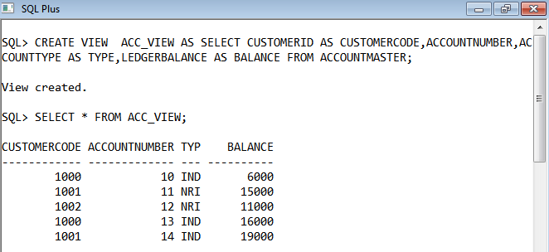

**32. Create a view on AccountsMaster table with name vAccs_Dtls. This view should**

**list all customers whose AccountType is ‘IND’ and their balance amount should not be**

**less than 10000. Using this view any DML operation should not violate the view**

**conditions.**

Solution : CREATE VIEW VACCS_DTLS AS SELECT CUSTOMERID AS CUSTOMERCODE,ACCOUNTNUMBER,ACCOUNTTYPE AS TYPE,LEDGERBALANCE AS BALANCE FROM ACCOUNTMASTER WHERE ACCOUNTTYPE='IND' AND LEDGERBALANCE>10000 WITH CHECK OPTION;

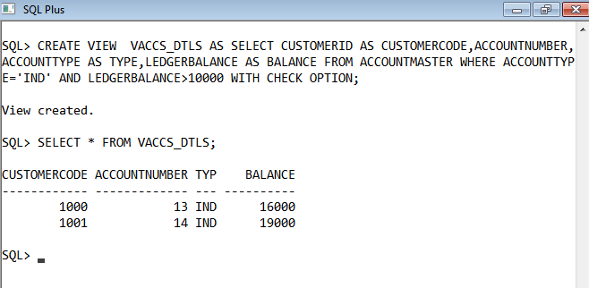

**33. Create a view accsvw10 which will not allow DML statement against it.**

Solution : CREATE VIEW ACCSVW10 AS SELECT * FROM ACCOUNTMASTER WITH READ ONLY CONSTRAINT READ_ONLY_VIEW;

View created.

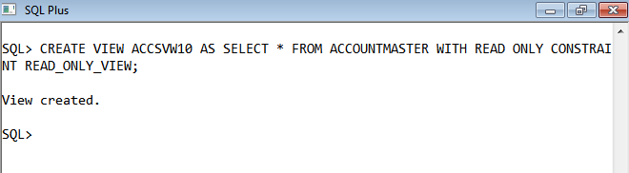

**34. Display the department from Staff table which has the highest salary by using**

**Inline View.**

Solution :

CREATE VIEW INLINE_VIEW AS SELECT * FROM STAFF_MASTER;

SQL> SELECT DEPT_CODE FROM INLINE_VIEW WHERE STAFF_SAL=(SELECT MAX(STAFF_SAL) FROM INLINE_VIEW);

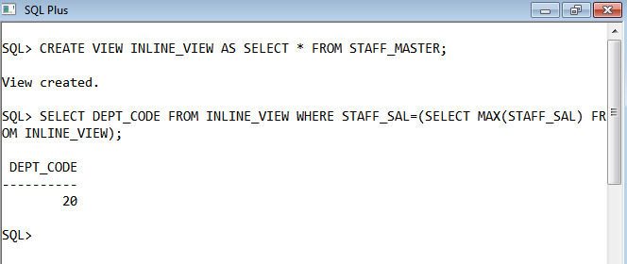

**35. List the top two highest earning employees in each department.**

Solution : SELECT * FROM (SELECT STAFF_CODE,STAFF_NAME,DEPT_CODE,STAFF_SAL,DENSE_RANK() OVER(PARTITION BY DEPT_CODE ORDER BY STAFF_SAL DESC) MYRANK FROM STAFF_MASTER) RANKED_MODELS WHERE MYRANK IN (1,2);

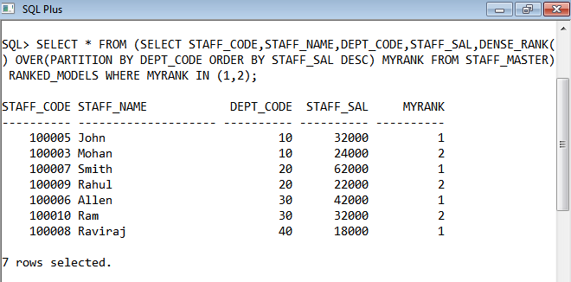

**36. Create a Sequence with the name Seq_Dept on Deptno column of Dept table. It**

**should start from 40 and stop at 200. Increment parameter for the sequence**

**Seq_Dept should be in step of 10.**

Solution :

CREATE SEQUENCE SEQ_DEPT INCREMENT BY 10

START WITH 40

MAXVALUE 200;

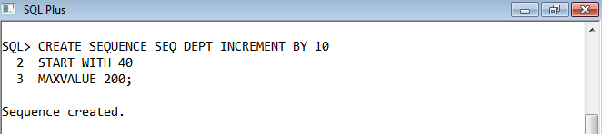

**37. Insert three sample rows by using the above sequence in Dept table.**

Solution : INSERT INTO DEPT VALUES(SEQ_DEPT.NEXTVAL,'LEARNING','11-FEB-15','PUNE');

SQL> INSERT INTO DEPT VALUES(SEQ_DEPT.NEXTVAL,'HR','02-MAR-11','MUMBAI');

SQL> INSERT INTO DEPT VALUES(SEQ_DEPT.NEXTVAL,'IT','23-DEC-13','BANGLORE');

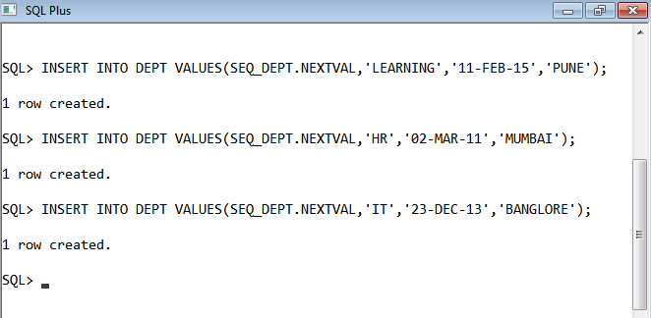

**38. Alter the above specified sequence with an increment by 5.**

Solution : ALTER SEQUENCE SEQ_DEPT INCREMENT BY 5;

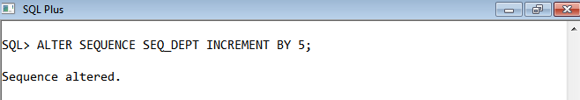

**39. Drop the Seq_Dept sequence.**

Solution : DROP SEQUENCE SEQ_DEPT;

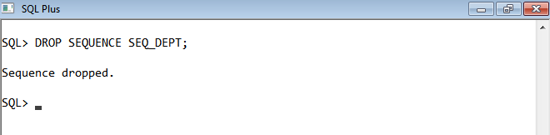

**40. Create a Unique index with the name No_Name on DeptNo and Dname of Dept**

**table.**

Solution : CREATE UNIQUE INDEX NO_NAME ON DEPT(DEPTNO,DNAME);

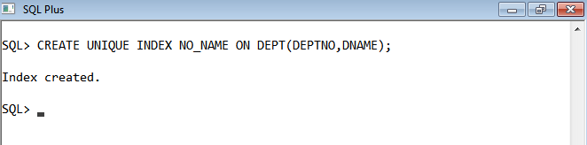

**41. Get information on the index No_Name from the Data Dictionary.**

Solution : SELECT INDEX_NAME,INDEX_TYPE,TABLE_NAME,TABLE_OWNER FROM USER_INDEXES WHERE INDEX_NAME=’NO_NAME’;

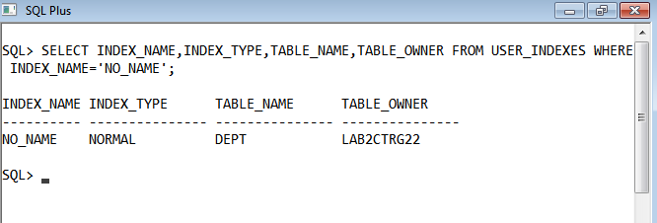

**42. Create public synonym synEmp for the EMP table.**

Solution : SELECT INDEX_NAME,INDEX_TYPE,TABLE_NAME,TABLE_OWNER FROM USER_INDEXES WHERE INDEX_NAME='NO_NAME';

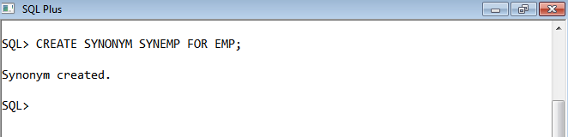

**43. Get Information on synonym synEmp from the Data Dictionary.**

Solution : SELECT SYNONYM_NAME,TABLE_OWNER,TABLE_NAME FROM USER_SYNONYMS WHERE SYNONYM_NAME='SYNEMP';

